Tacking a Horse
  - Purpose
This SOP is to provide guidance on for tacking racehorses at [Business Name].
Guidance provided in this document is of a general nature only. This document should be used as the foundation document for the preparation and use of site and task specific procedures, plans and risk assessments.
This SOP applies to tasks where workers are in close proximity to horses so should be read and applied in conjunction with these SOPs:
- “Reading and Responding to Horse Behaviour”
- “Safe Horse Handling Techniques”

  - Scope
This SOP applies to all individuals including stablehands, strappers, riders, trainers, and anyone else competent and authorized to tack racehorses- including the use of saddle, bridle, breastplate, and protective boots and other tack, at [Business Name].
This includes volunteers, and visitors under supervision.

  - Responsibilities
Employees and Contractors are responsible for:
- Adhering to the requirements of this policy or related policies
- Informing their manager immediately if it is suspected that a co-worker may be in breach of this policy.
- Having responsibility to take reasonable precautions for their own safety and health and that of others.
- Inform their manager immediately if an injury has occurred in the workplace.

Managers are responsible for:
- Managing adherence of the standards of this policy with employees
- Ensuring that all employees are aware of the expected behaviour at work related events.
- Taking all reasonably practicable steps to protect the health and safety of employees.
- Managing breaches of this policy.

  - Equipment and Materials Required
- Saddle (checked for fit and condition) Appendix A
- Saddle pad. Appendix B
- Bridle (including bit, reins, browband, and noseband) Appendix C
- Breastplate (if used) Appendix D
- Boots or wraps (clean and appropriate for horse) Appendix E
- Non- slip safety boots (helmet, gloves, protective vest as required)

  - Procedure:
Refer to ‘Safe Horse Handling’ & ‘Reading & Responding to Horse Behaviour SOPs.
- Ensure the horse is tied securely to a tie point.
- Brush the horse to remove dirt and sweat, especially where tack will sit.
- Clean hooves with a hoof pick if required.
- Check for injuries or soreness that may affect tack placement.
- Place saddle pad evenly on the horse’s back.
- Position the saddle gently over the pad, ensuring it sits behind the withers.
- Double-check alignment and comfort.
- Attach breastplate if used, ensuring it does not restrict movement.
- Secure the girth snugly but not too tight.
- Apply boots or wraps if required, starting from the front legs, ensuring even pressure and correct positioning.
- Gently insert the bit carefully into the mouth, placing the bridle over the ears, securing straps without pinching.
- Check cheekpieces, throatlatch and bit for proper fit—not too tight or loose.
- Walk the horse to check tack stability.
- Ensure all straps are secure and not interfering with movement

  - Safety Considerations
- Always wear PPE including enclosed footwear; gloves and helmets may be required for some horses or environments.
- Maintain a calm, confident presence when handling horses—avoid reacting to sudden movements or loud noises.
- Be aware of blind spots directly in front of and behind the horse.
- If a horse is agitated, stop and assess the situation before proceeding.
- Do not attempt tasks you are unsure or uncomfortable with. Always seek support from a more experienced handler or supervisor.
- When handling unfamiliar or young horses, work with a second experienced person.

  - Troubleshooting / Notes
- Avoid handling horses when you are rushed or distracted—focused, calm handling reduces risk of injury.
- The Australian Rules of Racing require that: While being led outside of a stable premises, every horse must have a bit in its mouth, and that bit must be attached to a lead or a stallion chain.

  - References
- Work Health and Safety Act (QLD) 2011
- Work Health and Safety Regulation (QLD) 2011

  - Version Control:
- Version: 1.0
- Effective Date: [Insert Date]
- Review Date: [Insert Date]
- Approved by: [Name & Title]

  - Appendix A: Saddle

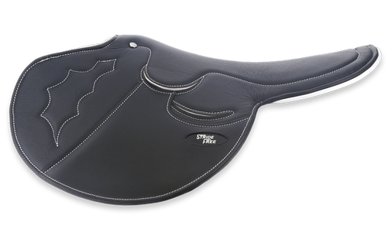

  - Appendix B: Saddle Pad
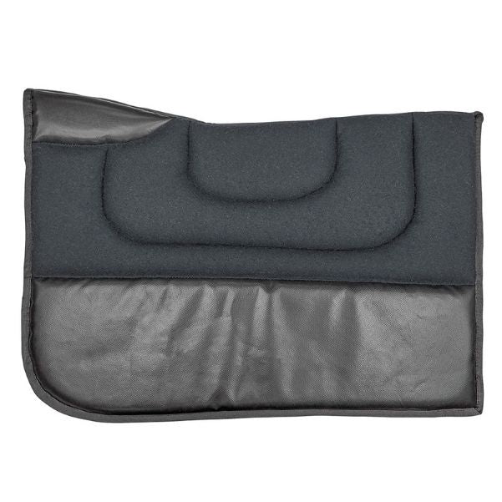

  - Appendix C: Bridle

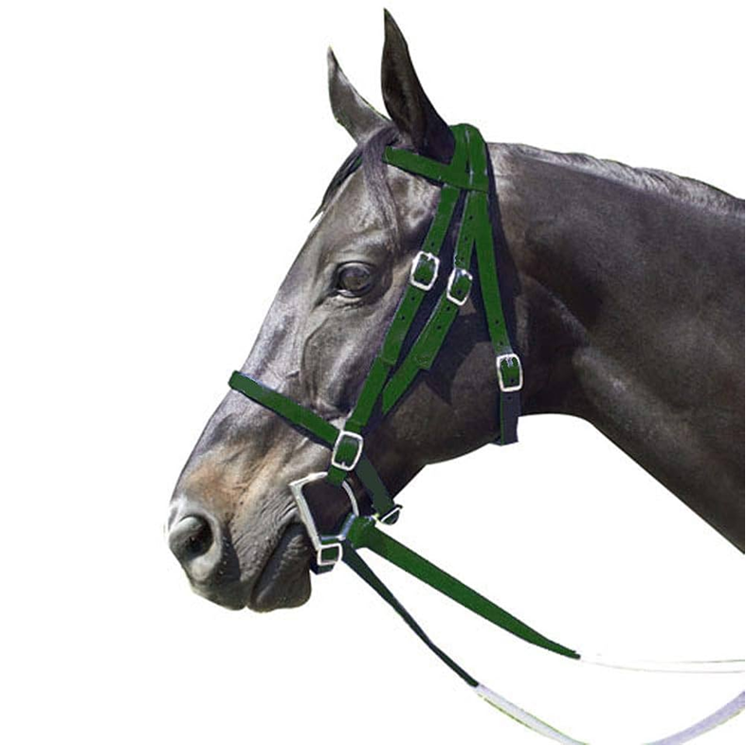

  - Appendix D: Breastplate

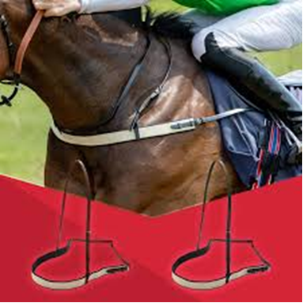

  - Appendix E: Boots or Wraps

