Manual Handling Procedure
  - Purpose
To ensure safe manual handling practices are followed in horse racing facilities across Queensland, reducing the risk of musculoskeletal injuries and complying with legislative requirements.

  - Scope
Applies to all workers, contractors, volunteers, and visitors performing manual handling tasks in stables, training centres, breeding farms, or racetracks.
Manual handling includes lifting, lowering, carrying, pushing, pulling, holding, restraining, or moving loads, as well as repetitive or sustained postures and movements.

  - Responsibilities
- Person in Control (PCBU/Business Owner/Manager): identify hazardous manual handling tasks, provide safe systems of work, and ensure staff are trained.
- Responsible Person (e.g. supervisor, foreperson, or delegated competent person): ensure staff follow safe manual handling techniques and that risks are controlled.
- Workers/Handlers: use correct manual handling techniques, follow safe work procedures, and report hazards, near misses, or injuries.

  - Procedure
- Planning and Risk Assessment
- Assess the load: weight, shape, stability, grip.
- Assess the environment: clear paths, good lighting, dry floor, adequate space.
- Identify risks (heavy, repetitive, awkward, live animals).
- Eliminate or reduce risks using mechanical aids or team lifting.
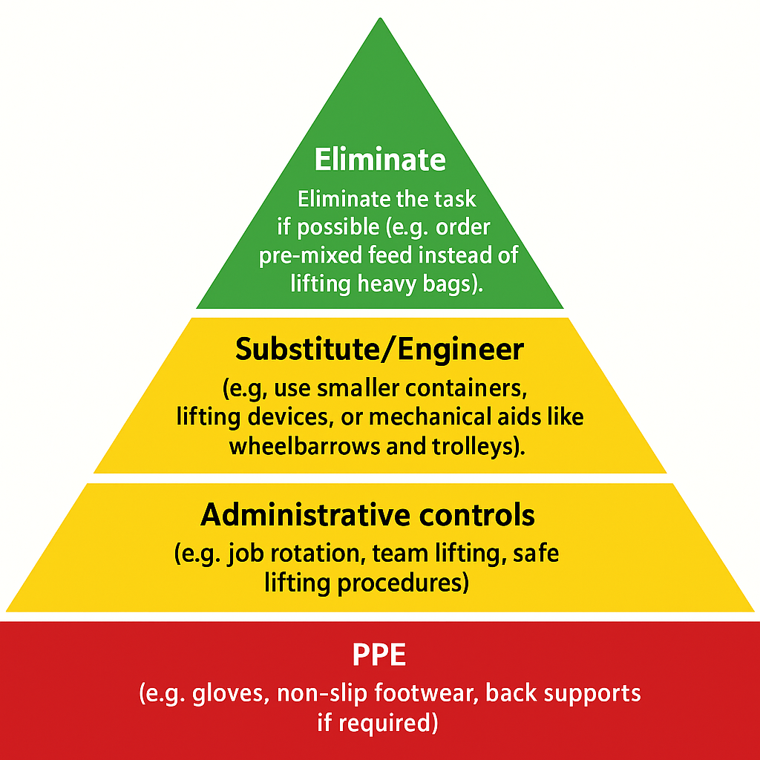

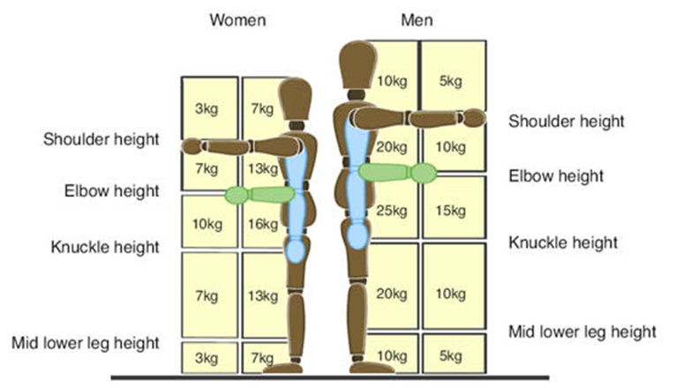
- Safe Handling Techniques
- Plan the lift by thinking before lifting and checking path is clear.
- Correct lifting:
  - Check load stability before lifting (avoid loads that may shift).
  - Bend knees, keep back straight.
  - Grip securely, lift smoothly using legs.
  - Keep load close to body.
  - Avoid twisting or jerking.
  - Turn with feet.
- Team lifting:
  - Communicate before lifting.
  - Share load evenly.
  - Nominate a leader to coordinate the lift and set the pace.
- Weight guidance
  - Up to 15kg – May be lifted individually if safe.
  - 16-20kg – Use mechanical aid or team lift if handled frequently or awkwardly shaped.
  - 20-55kg – team lift or mechanical aid only.
  - Over 55kg – Mechanical aid only (manual lift prohibited)
- Store items safely with heavy items kept between hip and shoulder height.
- Work organisation should include rotating tasks, taking breaks, and avoiding repetitive strain.
- PPE: gloves, non-slip footwear, and back supports if required.
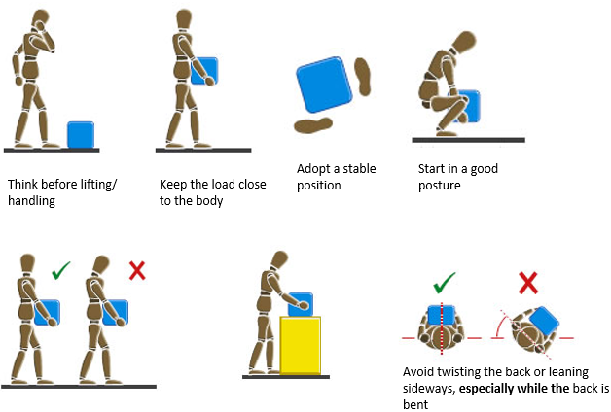
- Use of Mechanical Aids
- Use wheelbarrows, trolleys, pallet jacks, or lifting equipment where possible.
- Ensure aids are inspected and maintained.

- Hazardous Situations
- Do not handle loads that are too heavy, unstable, or unsafe without assistance.
- Take extra care when handling live animals or unpredictable loads.
- Stop work if conditions are unsafe (wet floors, unstable ground, storms, poor lighting, high winds).
- Ensure young or inexperienced workers are directly supervised when handling horses.

- Emergency
- If injury occurs:
  - Stop the task immediately.
  - Notify responsible person.
  - Apply first aid where safe. Do not move an injured person unless in immediate danger (e.g. fire, collapse)
  - Call 000 immediately if serious or life-threatening injuries occur.
  - Preserve the scene for investigation unless unsafe.

- Training & Competency
Workers must demonstrate:
- Safe lifting and carrying techniques.
- Team lifting coordination.
- Safe use of mechanical aids.
- Awareness of hazardous manual tasks (repetitive work, awkward postures, handling animals).
- Understanding of reporting procedures for hazards, injuries, and near misses.
- Knowledge of local workplace rules and WHS legislation.
- Training is recorded.

  - Safety Considerations - Manual Handling of Horse and Animals
When working with horses, remember they are unpredictable and can cause serious injury if not handled correctly.
General rules
- Handlers must never work alone with fractious or unbroken horses.
- Always approach horses calmly, from the front or side so they can see you.
- Speak softly to avoid startling them.
- Never stand directly behind a horse or wrap lead ropes around your hand/body.
- Use appropriate PPE (boots, gloves, helmet where required).
- Only trainer and competent staff should handle horses.
Handling and Leading
- Use halters, lead ropes, or bridles. Never drag or push.
- Lead horses on the near (left) side, keeping a safe distance from hooves.
- Walk, don’t run, and avoid sudden movements.
- When turning, lead the horse in a wide arc, keeping control of the head.
Restraint and Control
- If restraint is required, use safe, approved equipment (e.g. crush, stocks, hobbles).
- Never attempt physical restraint beyond your training or capacity.
- For veterinary or high-risk tasks, seek assistance from experienced handlers or vets.
- Always use the minimum force necessary. Restraint is for safety, not punishment.
Loading and Transport
- Ensure floats, trucks, and ramps are in good condition, non-slip, and well-lit.
- Load calmly and without force.
- Do not stand directly behind a horse when loading.
- Secure partitions and gates before moving the vehicle.

Risk Awareness
- Recognise signs of distress (ears pinned back tail swishing, stomping).
- Stop and reassess if a horse shows aggressive or unpredictable behaviour.
- Implement a “stop work and reassess” approach if handling becomes unsafe.
Contamination and Hygiene
- Wash hands thoroughly after handling horses, feed, tack, bedding, or waste.
- Wear gloves when handling manure, soiled bedding, medical waste, or injured animals.
- Do not eat, drink, or smoke while performing manual handling tasks around animals or contaminated materials.
- Treat all blood, saliva, manure, and urine as potentially infectious.
- Follow hygiene and infection control practices to minimise the risk of zoonotic disease transmission (e.g. Hendra virus, ringworm, salmonella).
Emergency
- If a person is injured, do not attempt to move them unless in immediate danger.
- Call 000 for serious or life-threatening injuries occur.
- Secure the animal safely away from the incident area.
- Preserve the scene for investigation.

  - Review
This procedure is reviewed annually or after any manual handling incident, and updated in line with WHS legislation, Australian Standards, or industry practices.

  - References
- Work Health and Safety Act (QLD) 2011
- Work Health and Safety Regulation (QLD) 2011
  - Part 4.2 Hazardous Manual Tasks
- Hazardous Manual Tasks Code of Practice 2021 (Queensland) – including horse-related activities.
- Workplace Health and Safety Queensland (WHSQ) – Horse-Related Activities Safety Guide.
- Relevant Australian Standards:
  - AS/NZS ISO 31000 – Risk Management
  - AS 1319 – Safety Signs for the Occupational Environment
  - AS 4024 – Safety of Machinery (where mechanical aids are used)

  - Version Control:
- Version: 1.0
- Effective Date: [Insert Date]
- Review Date: [Insert Date]
- Approved by: [Name & Title]

