Safe Horse Handling Techniques - Including Catching, Leading, Tying
  - Purpose
To provide guidance on safe handling techniques for horses, including how to catch, lead, and tie a horse safely and effectively.
The guidance provided in this document is of a general nature only. This document should be used as the foundation document for the preparation and use of site and task specific procedures, plans and risk assessments.
This SOP applies to tasks where workers are in close proximity to horses so should be read and applied in conjunction with these SOPs:
- Reading and Responding to Horse Behaviour

  - Scope
This SOP applies to all individuals responsible for handling horses at [Business Name], including staff, volunteers, and visitors under supervision.

  - Responsibilities
Employees and Contractors are responsible for:
- Adhering to the requirements of this policy or related policies
- Informing their manager immediately if it is suspected that a co-worker may be in breach of this policy.
- Having responsibility to take reasonable precautions for their own safety and health and that of others.
- Inform their manager immediately if an injury has occurred in the workplace.

Managers are responsible for:
- Managing adherence of the standards of this policy with employees
- Ensuring that all employees are aware of the expected behaviour at work related events.
- Taking all reasonably practicable steps to protect the health and safety of employees.
- Managing breaches of this policy.

  - Equipment and Materials Required
- Halter
- Lead rope
- Bit (outside stable premise)
- PPE (enclosed boots, gloves if required)
- Secure tying location
- Helmet (inexperienced handlers
- Bailing twine
  - Procedure
1. Catching a Horse
- Ensure you are calm, confident, and wearing appropriate PPE before approaching the horse.
- Walk toward the stall or yard and alert the horse of your presence using your voice.
- Enter the enclosure calmly and confidently, watching for signs of agitation such as pinned ears or tail swishing.
- Being mindful of a horse’s blind spots as described in the Reading and Responding to Horse to Behaviour SOP, approach the horse at a 45-degree angle to its shoulder, not from the front or rear.
- Avoid sudden movements and maintain a relaxed posture.
- If the horse moves away, pause, let it settle, and then approach again patiently.
- With your right hand, place the halter strap around the horse’s neck to maintain control. Using your left hand, slide the noseband of the halter over the horse’s nose, then secure the strap so that it fits snugly but comfortably
2. Leading a Horse
- Ensure the path is clear, avoiding congested areas, pedestrians, other horses, and potential hazards.
- Observe the horse’s behaviour, in line with the Reading and Responding to Horse Behaviour SOP.
- Stand on the horse’s left (near) side, holding the lead rope approximately 10-15 cm below the halter.
- Coil the remaining lead rope loosely in your left hand, ensuring that it is not dragging on the ground and could be stepped on by horse or handler—never wrap it around your hand or body.
- Begin walking forward calmly and confidently, using your body language to guide the horse.
- Maintain a steady pace and avoid rushing.
- Use voice cues and gentle pressure on the rope to encourage movement if needed.
- Keep an eye on the horse’s ears, eyes, and body language to detect discomfort or hesitation.
- In shared spaces, be mindful of other horses and handlers. Always pass on the right, so the handlers are passing by each other, and the horses are on the outside to minimise incidents.
- Never allow the horse to push past or walk ahead of you.
- When turning the horse, guide the horse away from your body where possible to avoid being trampled if spooked.
3. Tying a Horse
- Select a safe, designated tying location with a secure, immovable post or rail.
- The tying point should be at or above the horse’s wither height to prevent entanglement or pulling back.
- Always use a quick-release knot if being tied using a lead rope- see Appendix A
- Allow approximately 30–45 cm of slack in the rope—enough for some head movement but not so much the horse can step over it.
- If using cross ties, ensure that the rope/chains and fitting are in good condition.
- Never tie a horse with bridle reins, to a gate, fence rail, or any movable object.
- Check that the halter and lead rope are in good condition, with no frays or weaknesses.
- Remain nearby and observe the horse while tied. Do not leave the horse alone in unsafe or unfamiliar environments.

  - Safety Considerations
- Always wear PPE including enclosed footwear; gloves and helmets may be required for some horses or environments.
- Baling twine is often used as a safety precaution—if a horse is spooked and pulls back, the twine will break, allowing the horse to be settled.
- Maintain a calm, confident presence when handling horses—avoid reacting to sudden movements or loud noises.
- Be aware of blind spots directly in front of and behind the horse.
- If a horse is agitated, stop and assess the situation before proceeding.
- Do not attempt tasks you are unsure or uncomfortable with. Always seek support from a more experienced handler or supervisor.
- When handling unfamiliar or young horses, work with a second experienced person.

  - Troubleshooting / Notes
- If the horse refuses to be caught, use calm body language, and consistent voice cues.
- Avoid handling horses when you are rushed or distracted—focused, calm handling reduces risk of injury.
- The Australian Rules of Racing require that: While being led outside of a stable premises, every horse must have a bit in its mouth, and that bit must be attached to a lead or a stallion chain.

  - References
- Work Health and Safety Act (QLD) 2011
- Work Health and Safety Regulation (QLD) 2011

  - Version Control:
- Version: 1.0
- Effective Date: [Insert Date]
- Review Date: [Insert Date]
- Approved by: [Name & Title]

Appendix A – Quick Release Knot
Feed the tail end of the rope through the safety string loop.
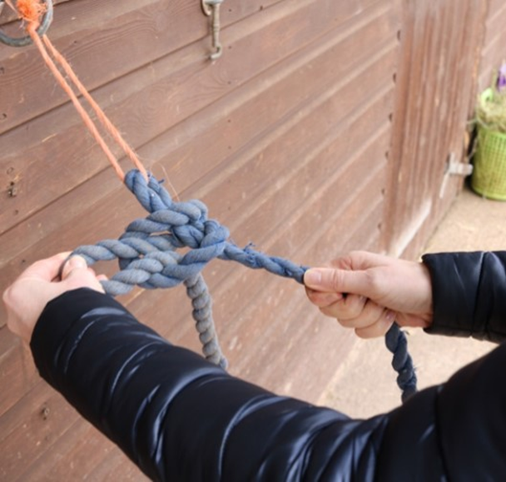

2. Pass the tail end over the rope and around to form a loop.
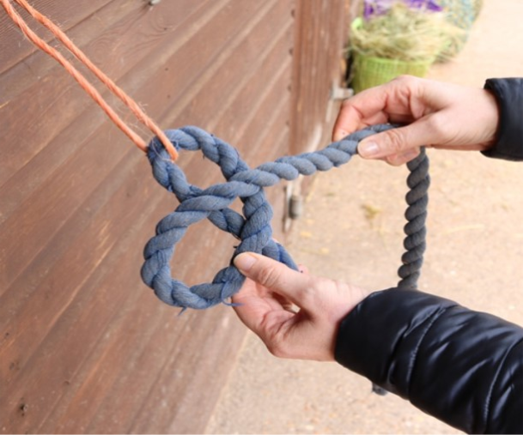
3. Fold the tail end and insert the doubled up end through the loop.
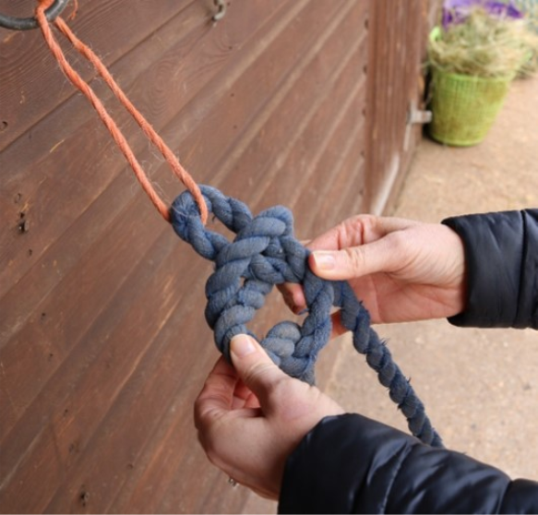
4. Tighten the knot so that it is snug. To release, simply pull on the rope end.
