Online Data Registration and Submission Guide
Data Registration:
- In the Web Browser enter the address https://www.racingqueensland.com.au/register
- Fill in your details to create an account with Racing Queensland.
- After successfully creating an account, email wagering@racingqueeland.com.au and inform us of the email address you used for the signup
- Once we receive your email, we will whitelist your account in our system, allowing you to submit data

Data Submission:
- Once you receive a confirmation email from us that your account has been successfully whitelisted, you can proceed with data submission
- In the web browser enter the web address https://www.racingqueensland.com.au/sign-in
- Enter the username password you used to register for Data submission.
- After successful login you will see the following page which is located in ‘My Account’. Please click the ‘Enter Wagering Data” bubble in the top right.
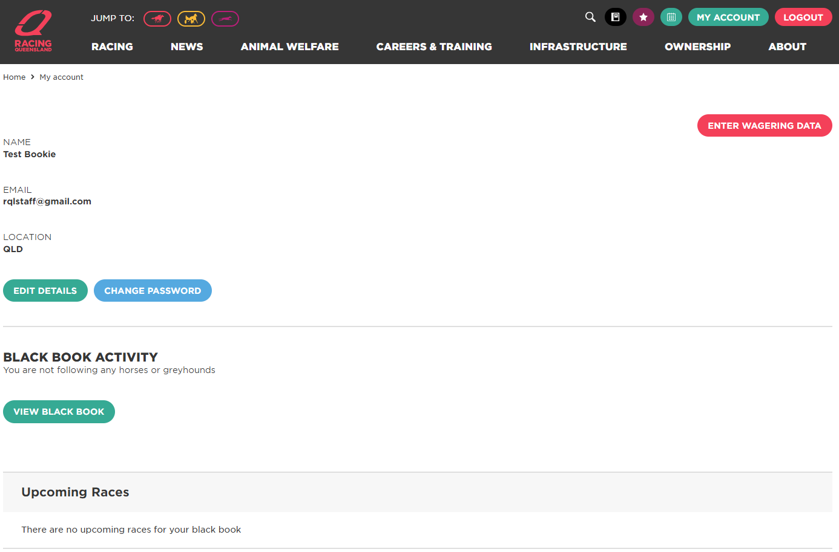

- You will then see the Wagering Data page that allows you to submit the required data.
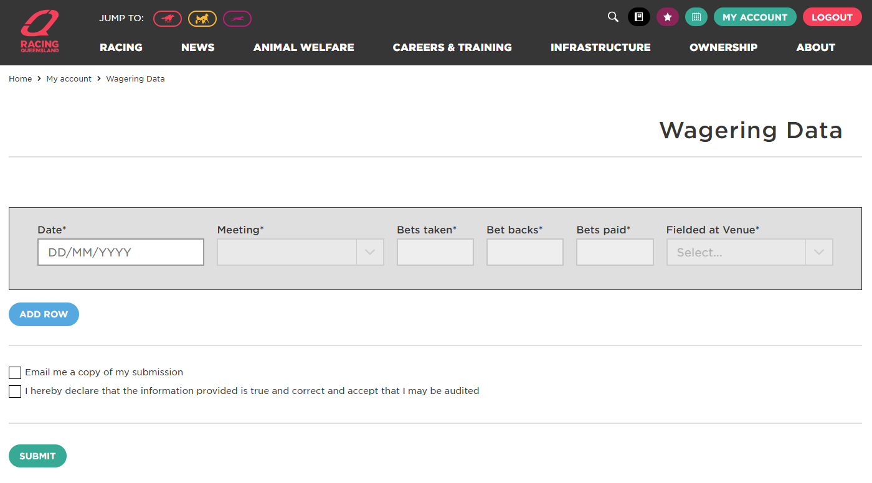
- Please enter all the meeting data; Date, Meeting, Bets Taken, Bet Backs, Bets paid and the venue you fielded at.
- This data is recorded at a meeting level, please do not provide your data at a race level.
- Once you have entered the data for all your meetings click Submit at the bottom of the page.
- Upon successful completion you will receive the message “Wagering Data has been
successfully saved.
- This will then allow Racing Queensland to begin the invoicing process

Racing Queensland will calculate your Race Field Fees consolidated for each month. These Race Field Fees are 1% of your turnover, where turnover is equal to your Bets Taken minus you Bet Backs.

If there are any changes to the data entered or you need a clarification about the invoice, please contact us via wagering@racingqueeland.com.au and we will update the data where necessary and send out a detailed list of data received and how the calculation has happened for the period.

