
Racing Queensland

How to use FTP to submit Wagering Data

Version 1.2: Dec 2024

Summary

As part of Racing Queensland’s (RQ) conditions for period effective 1 July 2025, all Authorised Operators with turnover of greater than $5m per annum will be required to submit monthly data, within five business days of the end of each month.

This document details the FTP (File Transfer Protocol) option for submissions. This method is an electronic form of submission.

If you have any questions, please contact wagering@racingqueensland.com.au

Steps

- Before starting, make sure you have received a username and password from RQ. If you don’t have this, please email wagering@racingqueensland.com.au.

- Ensure you have entered your data in the template you received from RQ. If you don’t have this, also, please email RQ using the email address above. The filename should be of the format: YYYYMM_ NameofAuthorisedOperator_Monthly.

- Make sure you are connected to the Internet. Open a File Explorer window (right click on the Windows Icon at the bottom left of the screen, and click File Explorer. Alternatively, press Windows key +E). Do not open Internet Explorer or any other internet browser

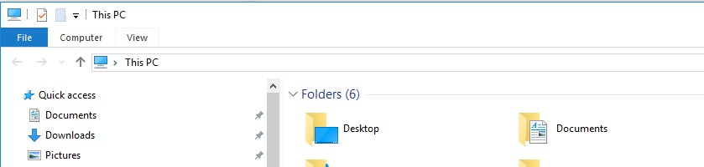

- In the Address section, type in ftp://172.105.186.47/

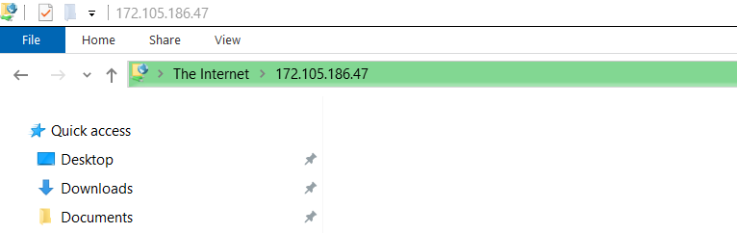

- Enter your username and password provided by RQ

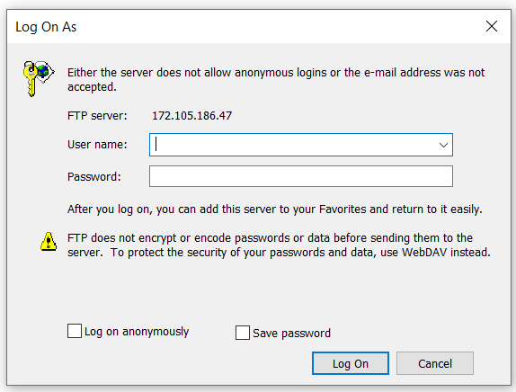

- In the Window that opens, copy and paste the file that you wish to submit.
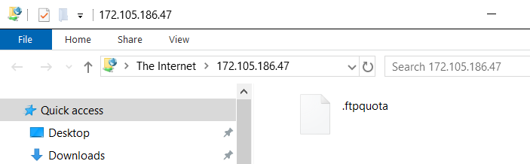

- Close the window.

NOTES:

- Please use the template that you got from RQ when populating your data. Do not create your own template or make any changes to the header, otherwise this will be rejected.
- The system will automatically notify you via email if there is an error with your file. For example, if you submit an incorrect Venue name, or a non-existent Meeting date in your file, the system will reject it, and send you an email informing you of the problem.
- When entering the Code, please use either Thoroughbred, Harness or Greyhound (and not eg. Gallops or Trots)

